Quiz 3 code

Ricardo Santos

Code

*//*

*// main.cpp*

*// PracticeLabs*

*//*

*// Created by Ricardo Santos on 3/13/19.*

*// Copyright © 2019 Ricardo Santos . All rights reserved.*

*//*

#include <iostream>

#include <fstream>

#include <iomanip>

#include <string>

**using** **namespace** std;

**int** main()

{

**int** numMonths;

**float** budget;

**float** expense;

**float** overunder;

**float** total = 0;

cout<<"Enter the number of months that you would like to analyze: \n";

cin>> numMonths;

**while**(numMonths <=0)

{

cout<< "Error you have entered an number less than 0\n";

cout<<"Enter the number of months that you would like to analyze: \n";

cin>> numMonths;

}

cout<<"Enter your amount for budget:\n";

cin>> budget;

**while**(budget < 100)

{

cout<< "Error your budget can not be less than $100\n";

cout<<"Enter your amount for budget:\n";

cin>> budget;

}

**for**(**int** expense1 = 1; expense1 <= numMonths; expense1++)

{

cout<<" Enter the amount of expenses for month "<< expense1<<".\n";

cin>> expense;

total += expense;

}

overunder = total - budget;

cout<< "You went $"<< overunder << " above your budget!\n";

**return** 0;

}

Run 1

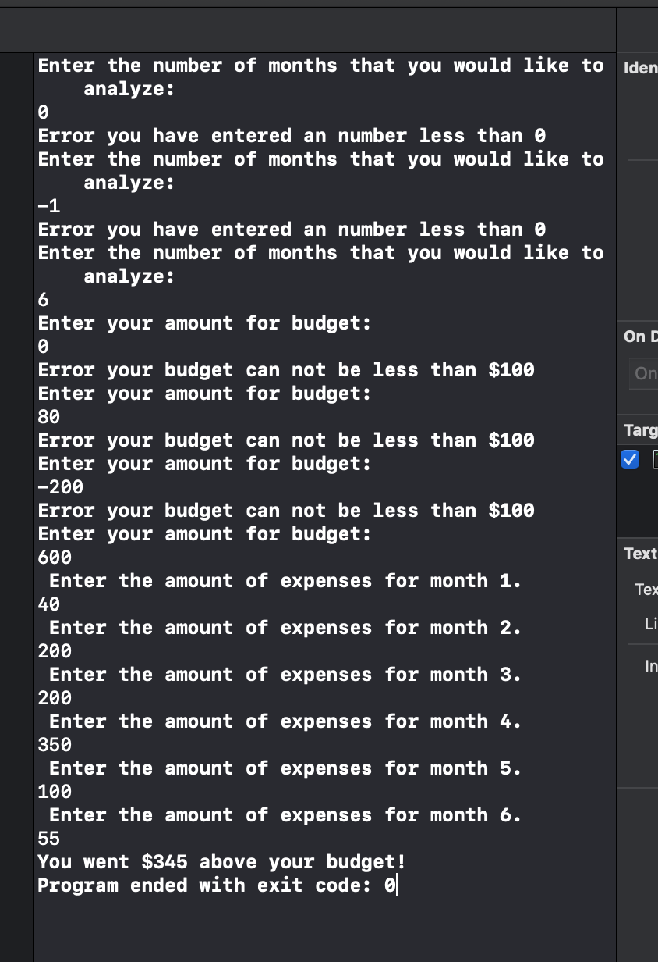

Run 2

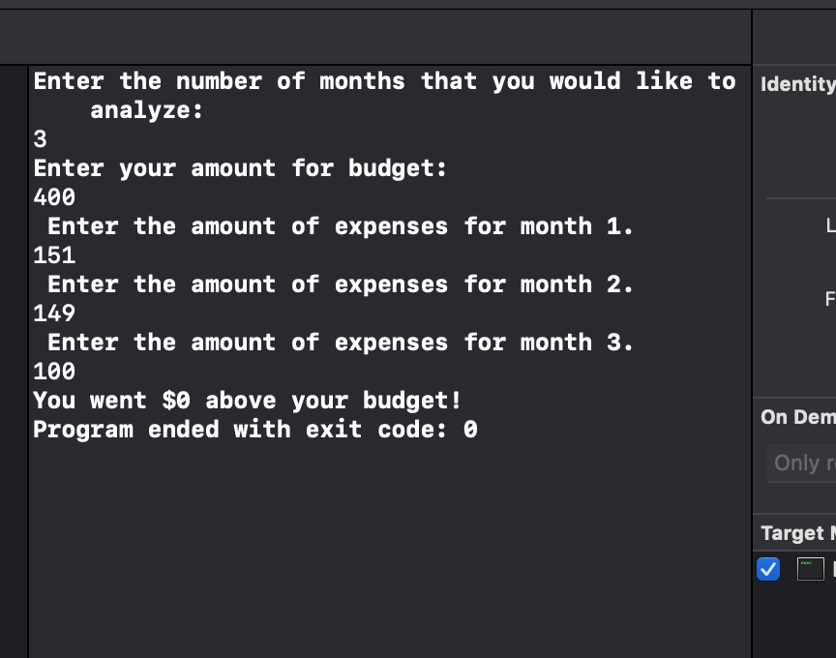

Run 3

